**A Parent’s Guide**

**What is PREVENT ?**

[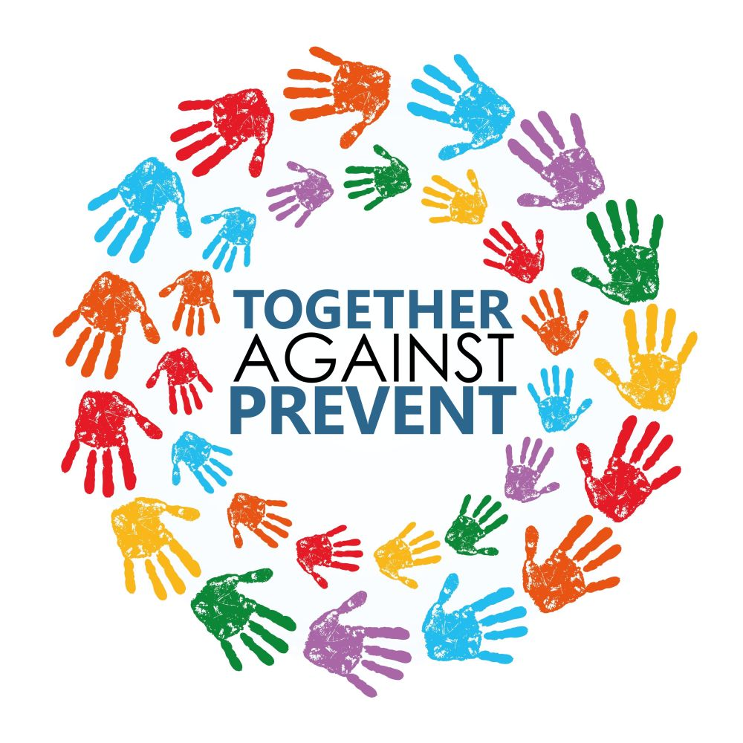](https://www.google.co.uk/url?sa=i&rct=j&q=&esrc=s&source=images&cd=&cad=rja&uact=8&ved=0ahUKEwigxs3byMbRAhVFOxoKHSx6A0EQjRwIBw&url=https://jews4big.wordpress.com/&bvm=bv.144224172,d.ZGg&psig=AFQjCNHHLBNtPeAlY09a46jBY9fDQERf1Q&ust=1484652740440180)

Grove Vale

Primary School

**What is the PREVENT strategy?**

Prevent is a government strategy designed to stop people becoming terrorists or supporting terrorists or extremists causes.

The Prevent strategy covers all types of terrorism and extremism, including the extreme right wing, violent groups and causes.

**How does the Prevent strategy apply to schools and Academies?**

From July 2015 all schools (as well as other organisations) have a duty to safeguard children from radicalisation and extremism.

This means we have a responsibility to protect children from extremist and violent views the same way we protect them from drugs or gang violence.

Importantly, we can provide a safe place for pupils to discuss these issues so they better understand how to protect themselves.

**How will we teach children about Prevent at Grove Vale?**

Many of the things we already do at Grove Vale Primary School help children become positive, happy members of communities and society also contribute to the Prevent strategy.

These Include:

* Exploring other cultures and religions and promoting diversity.
* Challenging prejudices and racist comments.
* Developing critical thinking skills and a strong, positive self-identity.
* Promoting the spiritual, moral, social and cultural development of pupils, as well as British Values.



**Should I be worried?**

Incidents of extremism and radicalisation are rare and as such when they do occur, make the news. As with all safeguarding issues, it is important to be vigilant, and not complacent, but also not to panic.

This guide will give you the information to make informed decisions and help safeguard your child.

**What is extremism and radicalisation?**

Prevent defines extremism as: ***“vocal or active opposition to fundamental British values, including democracy, the rule of law, individual liberty and mutual respect and tolerance of different faiths and beliefs. We also include in our definition of extremism calls for the death of members of our armed forces”***

Radicalisation is defined by the UK Government within this context as **“*the process by which a person comes to support terrorism and extremist ideologies associated with terrorist groups.*”**

**What are the British Values?**

[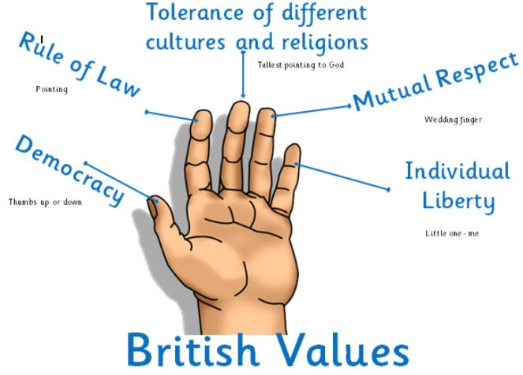](http://www.google.co.uk/url?sa=i&rct=j&q=&esrc=s&source=images&cd=&cad=rja&uact=8&ved=0ahUKEwjIme_c6MbRAhWBzxQKHRUFCYUQjRwIBw&url=http://maltonprimary.org/our-school/british-values/&psig=AFQjCNEpEc-jSErBAflyXnN1Sv-JyjOlCw&ust=1484661335438071)



**Social Media and Prevent**

Social media has become an essential part of how we live. Millions of young people use social media to share content. However, there is still a small minority of users who exploit social media to radicalise and recruit vulnerable people and young people.

**Social Media Platforms.**

 **You tube** is used to host videos, created by both official extremists and ordinary users. Videos are often shown on dummy accounts that are quickly deleted. Videos contain radical and extremist views and are often designed to groom, shock and entice young people into joining the organisation/group.



Extremists tend to use **Facebook** to share content, such as news stories and you tube videos among their peers and young people.

**Twitter** is another social media platform. Extremists can stay relatively anonymous through their accounts and they tend to share material with large numbers of people.

**Instagram** is used by radical supporters to share the photosets frequently produced by extremist groups. A well-known group known as ISIL use Instagram to share pictures of their life in Syria, often showing landscape and images suggesting they are living a happy life.

**Tumblr** the blogging site, is exploited by fighters to promote longer, theological arguments for travel. Tumblr is popular with female extremists.

**Private Messaging** – This is a function on many social media sites and extremist and radical supporters frequently encourage others to message them on closed peer-to-peer networks when asked for sensitive information such as how to travel to the region, what to pack and who to contact when they arrive.

Popular private messaging apps include WhatsApp, KIK, SureSpot and Viber.

**Ask.fm** - People considering travel to Syria or Iraq sometimes use Ask.fm to ask questions about Travel, living conditions, recruitment, fighting and Ideology. Answers given by supporters are always encouraging, saying all difficulties will be solved if they travel to the region.



**What is ‘*extremism and radicalisation’* is not!**

We live in a wonderfully diverse world, with both differences and similarities to celebrate. Exploring religious and different social beliefs, in a peaceful and non-violent way, is part of growing up and should not be confused with something more sinister.

The best way to PREVENT extremism and radicalisation is by open discussion and increased understanding of each other.



**What can I do as a parent to help my child?**

You know your child better than anybody else. Having open, honest conversations on a regular basis will allow your child to explore new ideas in a safe environment.

Talk to your child about their online viewing. Social media such as YouTube and Facebook can be used to groom children towards a certain point of view.

Discuss different points of view concerns topics in the news, modelling that there is always more than one point of view.

Encourage your child to take an active part in their local community. This could be part of a sports club, social group, volunteering. Getting out, meeting and talking to people around you helps to understand and become part of a community.

**Who should I contact if I have a concern?**

**For High risk Prevent enquiries or emergencies**

Tel: 999

**For low risk or non-emergencies**

Speak to Mrs Connop our school Head Teacher and Designated Safeguarding Lead.

Tel: 101 and ask for the Local Policing Team

The Anti-terrorist Hotline

**Support and Advice**

[www.net-aware.org.uk](http://www.net-aware.org.uk) – Look at websites your child is viewing in detail and assess for yourself if they are safe for your child to use.

FAST [www.Familymatters.org.uk](http://www.Familymatters.org.uk) Being a parent can involve tough choices and decisions seek advice from the family matters team.