Assessment Policy
June 2018

Contents

Assessment policy | 3
Aims | 3
Arrangements for the governance, management and evaluation of assessment  Roles and responsibilities | 4
Governors | 4
Senior leadership team | 4
Teachers | 4
Teaching assistants | 4
Parents and carers | 4
How assessment outcomes are collected and used | 5
In-school formative assessment | 5–6
In-school summative assessment | 7
Use of tests in school | 8
Arithmetic and Number Progress Tests | 8
Summative Tests | 8
Tracking pupil progress | 8
Nationally standardised summative assessment | 8
Assessing children with SEND | 9
Assessing the most able children | 9
Assessing children in EYFS | 9
School year assessment overview | 10

Assessment policy
Our assessment policy is aligned to our curriculum and is an integral part of the learning process. The curriculum is mapped out against end of year, age-related expectations (AREs), ensuring quality in-depth teaching and learning. Central to this is a focus on formative assessment as a tool to guide learning. Assessment in our school generates continuous improvement and supports achievement. It takes place in all year groups and across all subject areas. All assessment in our school is meaningful and avoids unnecessary recording or tracking. Assessments take the form of observations, discussions, formal assessment of written work and tests. Our approach is inclusive, and we strive for children of all abilities to achieve.

This assessment policy is a live document, reviewed regularly to improve assessment practice in school and to remain up to date with government guidance. Evaluation of teaching and learning is linked to the continual professional development of all staff to ensure teacher expertise in curriculum, pedagogy and assessment.

Aims
- Ensure that all children make good progress and achieve.
- Track children’s attainment and progress, against AREs, to inform teaching and learning.
- Provide a consistent approach across all subject areas and age phases.
- Ensure formative assessment and skills analysis are an integral part of day-to-day teaching and learning, in every classroom, enabling us to identify children who are falling behind in their learning or who need additional support, including the most able.
- Ensure assessment contributes to the early and accurate identification of children with special educational needs and any requirements for support and intervention.
- Share meaningful feedback (written and oral) with children, highlighting their strengths and helping them to understand what they need to do to improve.
- Set children challenging goals, given their starting points, and ensure they make good progress towards meeting or exceeding them.
- Provide comprehensible information to parents and carers on how well their children are doing in relation to expected standards.
- Hold informative and productive conversations with parents and carers on supporting their children’s learning effectively.
- Ensure as many children as possible are ready for their next steps in learning at key transition points.

Arrangements for the governance, management and evaluation of assessment
Roles and responsibilities

Governors:
- monitor whole school data
- monitor assessment practices in school

Senior leadership team:
  - moderate teacher assessments and tests
  - set realistic whole school targets
  - analyse data for school improvement and reporting
  - lead and monitor whole school assessment practices
  - provide training for teachers to ensure a good understanding of assessment and assessment practice

Teachers:
- regularly use ongoing formative assessment and skills analysis
- make summative judgements at defined points in time
- provide feedback to pupils and set realistic targets for individual pupils
- provide assessment information to the senior leadership team, parents and pupils

Teaching assistants:
- provide feedback to teachers on pupil progress and attainment

Parents and carers:
- attend meetings with teachers to discuss their children’s attainment and progress
- support children with their home learning

How assessment outcomes are collected and used
We use three key forms of assessment:
- in-school formative assessment
- in-school summative assessment
- nationally standardised summative assessment

In-school formative assessment
Formative assessment takes place during learning and:
- assesses knowledge, skills and understanding
- identifies children’s strengths
- highlights gaps in learning
- tackles children’s misconceptions
- identifies the next steps in learning
- diagnoses need for support or intervention
- informs teacher planning and reporting

Types of formative assessment include:
- rich question and answer sessions during lessons
- marking of pupils’ work
- observational assessment, such as during the Innovate stage
- regular short recap quizzes
- scanning work, from across the curriculum, for pupil attainment and development
- adult and peer feedback and response partners
- child self-assessment and reflection on learning, such as during the Express stage

We use Cornerstones Assessment to support our formative assessment methods. Essential Skills, based on end of year AREs are used to inform planning in all subjects. They break the programmes of study into end of year group expectations to show a clear progression. For each subject the skills are organised into aspects, allowing teachers to monitor children’s breadth of understanding.

We use the Essential Skills in two formats:
- a subject-specific format, showing annual progression – this is used by subject leaders to track progression across school in particular subjects
- a year group format, showing all subjects for each year group – this is used by teachers to support planning and target setting

Cornerstones Developmental Skills provides a learning progression through the national curriculum with end of term AREs for English and mathematics. Teachers use the Developmental Skills to support differentiation during lessons and to plan the next learning steps for individual pupils or groups. The Developmental Skills are organised into aspects within each subject area which ensure the children have the opportunity to acquire a breadth of skills. ‘Depth of learning’ is achieved once a child has demonstrated an ability to confidently apply these skills in a range of contexts and across other subjects.

Assessment and Moderation Grids (AMGs) are used to assess and record attainment in reading, writing and mathematics and all subjects online. The grids contain key developmental skills and enable teachers to measure, track and share children’s attainment. We use them to record formative and summative assessment and provide the supporting evidence necessary to make age-related judgements on children’s attainment. If a child has achieved the vast majority of skills on a grid, they can be judged to be working at that ARE. If a child is working below the age-related statements on a grid, they are assessed using the previous grid. A child showing that they can use and apply the vast majority of skills from a higher ARE can be judged as working at greater depth within the expected standard or working above the expected standard.
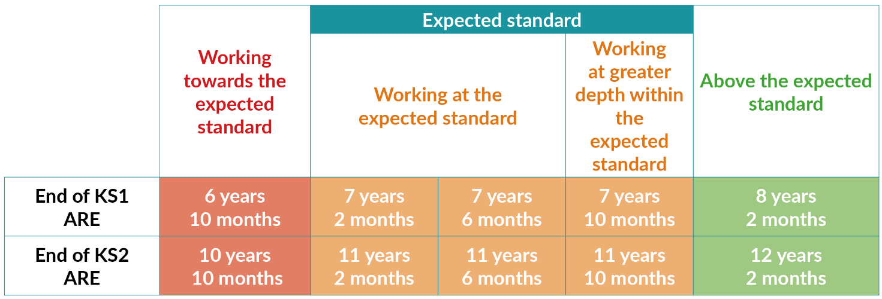

Teachers use the AMG’s to moderate work at similar levels across school and with other schools to ensure that their judgements are sound. Summative assessment judgements are based on professional judgement and a variety of evidence.

Our teachers ensure that children are not accelerated too quickly through narrow strands of the curriculum but ensure that they are fluent in all aspects of the ARE before moving them on. The Cornerstones progression of Developmental Skills allows for children’s learning to be extended at an appropriate pace.

In-school summative assessment
In-school summative assessment sums up what a child has achieved over a period of time, relative to learning aims. The outcomes of in-school summative assessments support teachers in making rounded professional judgements on the attainment of a child at a particular time in specific subjects or subject areas. In-school summative assessments inform teachers and senior leaders on attainment and progress within specific groups, classes, year groups and across school.

Summative assessments are carried out at the end of a project, term or year and provide further evidence and ratification of formative assessment. They take the form of written tests, observations, assessment tasks, photographs or learning journals.

As national curriculum levels have been phased out, our approach is to map children’s progress against AREs. These are based on the average age of pupils at the end of each term, irrespective of an individual pupil’s actual age.

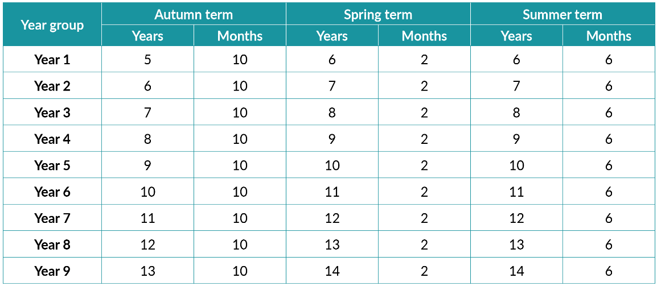

Pupil’s progress is measured in years and months, with 12 months being the expected progress in one year.

Use of tests in school

Summative Tests
Cornerstones Summative Tests are used to ascertain what pupils have learned, on a termly basis, in relation to the programmes of study outlined in the national curriculum for mathematics. The tests are based on the statutory programmes of study for Key Stage 1 and Key Stage 2.
The relevant Cornerstones Attainment and Gap Analysis Tool helps teachers to use the results from the tests to inform planning, make summative judgements and compare against other schools nationally.

Tracking pupil progress
We use the Cornerstones system to set targets, track pupil progress and attainment, and create reports to ensure assessment is an integral part of classroom practice and school improvement. Data from teacher assessments and judgements are entered. This is ratified termly for English and mathematics and bi-annually for foundation subjects. The senior leadership team monitor the progress and attainment of individual pupils, groups, classes or year groups and school as a whole. The system highlights children whose progress is below the expected level and who may need additional support or intervention. Progress and attainment information is communicated to all stakeholders, including parents, governors and Ofsted.

Nationally standardised summative assessment
We ensure all statutory assessments are administered in accordance with guidance and reported to all stakeholders as appropriate. Nationally standardised summative assessment provides information on how pupils are performing in comparison to pupils nationally and how the school is performing in comparison to schools nationally. Results from national tests are used to inform in school summative assessment and in-school assessment practice.

Assessing children with SEND
Our school has high aspirations for the achievements of pupils with SEND. We use information from teacher assessments and testing to support the diagnosis of learning difficulties and highlight any requirements for support or intervention. Progress for all children is measured in the most appropriate way for the individual child. Progress in communication or social skills may be considered as well as alternative methods of recording, such as learning journals and photographs.
Assessing the more-able children
Children who achieve all age-related statements early in a term will be judged to have shown depth of learning in that subject or subject area. They can then be judged against the statements in a subsequent grid.
Teachers can also refer to the Cornerstones ‘Problem solving, depth and fluency’ Essential Skills document which allows children to demonstrate their mastery of mathematical concepts through problem solving.
For children working above Year 6 ARE, we use the Cornerstones Higher Order Essential Skills for English and mathematics. These have been created with reference to the national curriculum programmes of study for Key Stage 3. We can assess children against AREs up to 14 years 6 months.
Assessing children in EYFS
Our EYFS practitioners base their assessments on their knowledge of the child through observation and interaction in a range of daily activities and events. Our EYFS provision enables each child to demonstrate their learning and development fully. Embedded learning is identified by assessing what a child can do consistently and independently in a range of everyday situations. Our EYFS assessment presents a holistic view of a child’s learning and development and our judgements take account of contributions from a range of perspectives including the child, their parents and other relevant adults.
Teachers use SIMS to track children’s progress in the typical behaviours for 22–36 months, 30–50 months and 40–60+ months and the ELGs. Tapestry and paper based learning journeys are used to collect evidence to inform termly assessment data and tracking.
Reporting to parents section
There are 3 parent’s evenings a year to communicate with the parents. (November – Settling in and after the first PPM) and (February – progress report). In July an opportunity is given to the parents to discuss the end of year report.
Effort reports are also sent home to parents at the end of the Autumn and Spring term after pupil progress meetings. Pupils who are not on track are informed of support in school and offers support to parents at home.
There are other strategies in place to keep parents fully informed of their child’s progress in school. We encourage the parents to contact school if they have concerns about any aspect of their child’s work. Also teachers are available after school on the playground for parents to talk to and members of the Senior Management Team before and after school on the playground.

Feedback to pupils
Feedback is very important as it tells children how well they have done and what they need to do next to improve their work. We have an agreed code for marking and feedback, as this ensures we are consistent across our school. (See marking and feedback Policy).

Monitoring and review
The assessment co-ordinator and subject leaders are responsible for monitoring the implementation of this policy. Staff are given time to collate evidence for their subject areas and time to look at their assessments for each subject area.
Throughout the academic year there are allocated times for monitoring to take place in various forms. These forms are lesson observations, book trawls, learning walks, pupil progress meetings, moderation meetings, planning analysis and pupil conferencing. There is a monitoring calendar which outlines when and who carry out these monitoring sessions.

Monitoring is carried out to: -

- Establish how well we are performing.
- Identify school strengths and weaknesses to ensure the best possible standards of teaching and learning.
- Celebrate our strengths.
- Ensure that our future actions are targeted to address the weaknesses (monitoring for a purpose).
- Ensures that pupils progress and develop and attain the best possible standards.
- Ensure that the school provides a positive, purposeful and vibrant learning environment.
- Ensure that pupils have a positive attitude to their work and that their behaviour is good.

Links
Marking and Feedback policy
Teaching and Leaning policy

School year assessment overview

Autumn 1 | - Ratify/moderate summer data  - Data Report to governors/other required bodies  - Nursery and Reception baseline  - Teacher performance management  - Pupil progress review for summer term/target setting meetings
Autumn 2 | - Summative tests for Maths, Reading and SPaG  - Pupil progress Meetings (data)  - Moderation in year groups Input data to tracker  - Analyse data/moderation
Spring 1 | - Report to governors/other required bodies  - Teacher performance management review  - Pupil progress review for autumn term
Spring 2 | - Summative tests for Maths, Reading and SPaG  - Nursery and Reception data input and analysis  - Moderation in year groups  - Pupil progress Meetings (data)  - Input data to tracker  - Analyse data/moderation
Summer 1 | - Pupil progress meetings reviews  - Monitoring and evaluation of core/non-core subjects  - National testing in Y2 and Y6
Summer 2 | - Teacher performance management end of year review  - EYFS Profile data collection and moderation  - Summative tests for Maths, Reading and SPaG  - Pupil progress meetings (data) (including a review of interventions)  - Y1 Phonic Screening  - Y2 and Y6 teacher assessment against interim frameworks  - Transition meetings and class information handover  - Finalise teacher assessments – input into tracker  - Data analysis  - Data review meetings – action plans

Our school aims to ensure that all personal data collected about staff, pupils, parents, governors, visitors and other individuals is collected, stored and processed in accordance with the General Data Protection Regulation (GDPR) and the expected provisions of the Data Protection Act 2018 (DPA 2018) as set out in the Data Protection Bill.

Creative learning with backbone
Office: 03333 20 8000
Email: support@cornerstoneseducation.co.uk
www.cornerstoneseducation.co.uk
Facebook: Cornerstones Education Ltd
Twitter: @Cornerstonesedu

Copyright © 2016 Cornerstones Education Limited

